



Essay / Assignment Title:
End-to-End NLP Pipeline for Chatbot Application Development
Programme title:
Natural Language Processing
Name:
Mahla Alimardani, Q1107537
Year:
2025

CONTENTS

Contents
CONTENTS 2
INTRODUCTION 4
CHAPTER ONE 5
CHAPTER TWO 17
CHAPTER THREE 19
CHAPTER FOUR 21
CONCLUDING REMARKS 27
BIBLIOGRAPHY 28
APPENDIX (if necessary) 29

Statement of compliance with academic ethics and the avoidance of plagiarism

I honestly declare that this dissertation is entirely my own work and none of its part has been copied from printed or electronic sources, translated from foreign sources and reproduced from essays of other researchers or students. Wherever I have been based on ideas or other people texts I clearly declare it through the good use of references following academic ethics.
(In the case that is proved that part of the essay does not constitute an original work, but a copy of an already published essay or from another source, the student will be expelled permanently from the program).

Name and Surname (Capital letters):

........MAHLA ALIMARDANI..............................................................................................................................

Date: ............02...../..08..../.2026........

INTRODUCTION

Introduction
Chatbots have become common in contemporary customer care to automate intent discovery, information retrieval and response generation. The development of NLP has turned chatbots into data-driven and rule-based systems, such as classical machine learning and transformer-based architectures. Although the conversational fluency has been enhanced by these improvements, there has been a challenge of ethics, safety, and reliability.The misclassification of intent may result in wrong response, failure to solve a problem or poor handling of sensitive information in customer facing environments, which has direct impact on user trust. These risks are further increased by prejudices in training information, label contamination, and uneven distributions of intent, and the issue of responsible chatbot design is more of a crucial need than an incidental one. The current project investigates these issues based on the data of customer support on Twitter and compares a classical TF -IDF + Logistic Regression baseline with the fined-tuned DistilBERT. In addition to performance measures, the analysis will focus on failure, ethical risks, and trade-offs. It also speaks of mitigation measures like confidence levels, fallbacks that are rule-based and human-in-the-loop policies as critical elements of reliable conversational AI systems.

CHAPTER ONE

Preprocessing and Exploratory Analysis for Chatbot Inputs
The following output provides a small sample of the raw Customer Support on Twitter data including information related to their tweet like tweet id, author id, inbound, created at, and the text of the tweet. The fact that there are user-generated messages and company-generated responses indicates that the data is a complete thread of conversation and not a single query by a user. This difference is essential as far as the design of a chatbot is concerned. A chatbot does not work based on messages written by human agents, this is an input of the user. Combining these two functions would bring about extreme levels of label and distributional noise to downstream models. Earlier research on intent detection highlights the importance of separation of speaker roles in order to do intent modeling effectively in dialogue systems.This screenshot hence encourages the preprocessing decision to fixated inbound user messages prior to any linguistic processing and modeling.
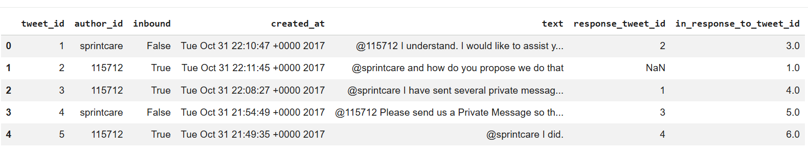
The dataset of inbound customer support messages (following filtering and the removal of empty messages) had over 1.5 million user messages, indicating the size and noisiness of customer support data in the real world. This attribute shapes the choice of models and encourages sampling methods of computationally-intensive methods like embeddings and transformers. According to the retrieval outcome, there are high scores of cosine similarity (> 0.91) between user queries and relevant messages even in the case of lexical variation such as charged twice, wrongful charge, refund me. This illustrates that embedding-based approaches such as Word2Vec are useful in capturing semantic similarity beyond the wording surface meaning and thus are very appropriate in retrieval-based chatbot systems(Ritter et al., 2011; Mikolov et al., 2013).

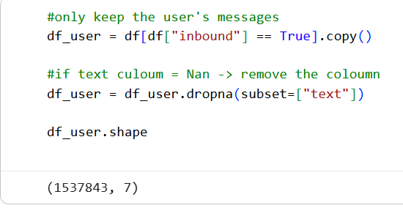
the code gives an example of a text cleaning pipeline, which is used to clean up noisy Twitter data. There is normalization of user messages that includes lowercasing of text, the replacement of URLs, mentions, and hashtags with tokens (URL, USER, HASHTAG) that are symbols, deleting all non-alphanumeric characters, and standardization of whitespace. This method minimizes noise, but structural cues are not lost, and the model is made aware of whether there is some links or mentions without being overfit to particular entities, which is a best practice in social media NLP. The following preprocessing involves linguistic normalization, sampling and word2vec preparation. The text is tokenized, stopwords and punctuations are filtered out, words are lemmatized with spaCy and numbers are converted to one single NUM token. Lemmatization also lowers the variation of lexical and enhances generalization, which has been said to advantage intent detection in the conversational system (Manning et al., 2008). Lastly, 30,000 user messages will allow training Word2Vec effectively and offer an adequate range of semantics, which is a typical trade-off in applied NLP when one has limited computing resources (Goldberg and Levy, 2014).
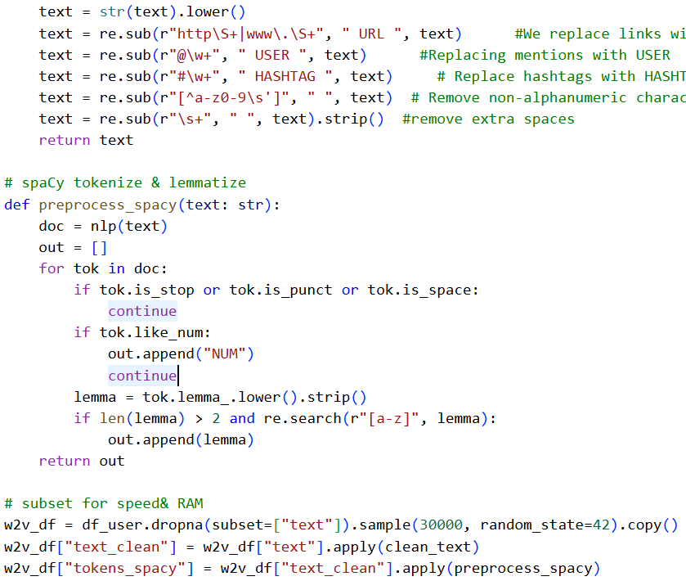
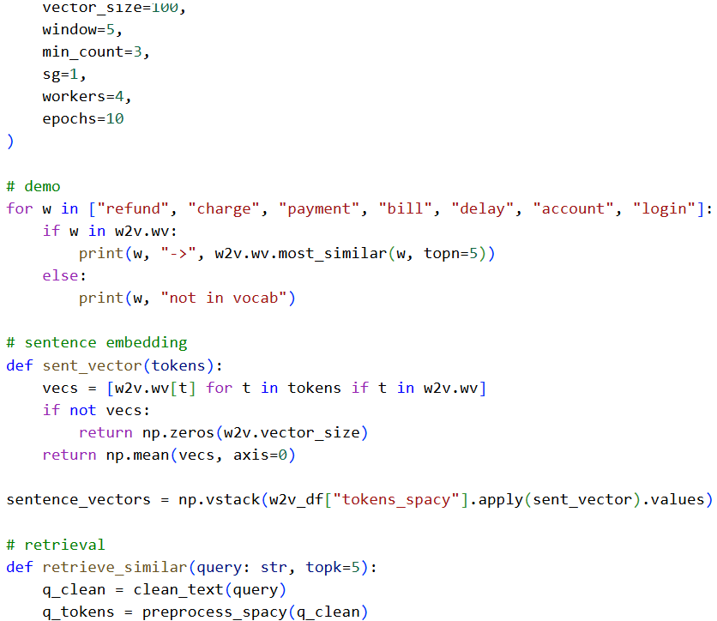
- Text Similarity Analysis
the text similarity results are the last step of a semantic retrieval pipeline that uses Word2Vec embeddings and encodes user messages as averaged word vectors which are compared by cosine similarity. The fact that the scores of similarity are high (around 0.91-0.93) allows assuming that the semantic correspondence between the query provided by the user and the messages returned by the system is high. Notably, this similarity comes about by the similarity of meaning and not the exact overlap of words. Various manifestations of billing and refund-related problems are appropriately clustered, which proves one of the strongest benefits of embedding-based approaches to bag-of-words classification models, including TF-IDF. This feature is especially useful in the support chatbots of customers, where different users tend to refer to the same issue in various terms. These findings indicate that semantic similarity is useful in facilitating retrieval-based chatbot elements by correlating new queries with previous cases. Nevertheless, similarity does not necessarily imply the same intention and correct reaction as closely related problems can demand varied solutions. Thus, combination of similarity-based retrieval with intent classification, confidence thresholds or rule-based restrictions is the future practices of chatbot systems.
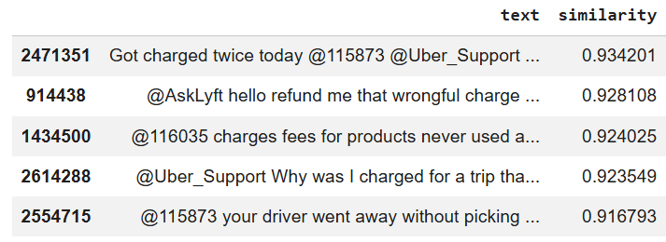
- Token Frequency (User Messages)
This figure depicts the 20 most common tokens of the user message content during after-processing and spaCy-based tokenization. NUM is the most common token and denotes the normalization of all numeric expressions, and it is especially applicable in customer support data where customers often state order numbers, dates, charges, and phone numbers. Such a strategy minimizes the vocabulary dispersion, but still maintains the vital semantic indications of the purpose, such as billing or account problem. The high frequency of such tokens as service, help, customer and work underlines the problem-oriented character of the dataset, whereas the words like polite such as thank display the availability of the social language along with technical requests. In general, this distribution justifies that the dataset is adequately distributed according to customer support intents, preprocessing was effective to minimize noise, and token frequency is not a useful predictor of fine-grained intent detection, which serves as a motivation to consider semantic models beyond bag-of-words models.
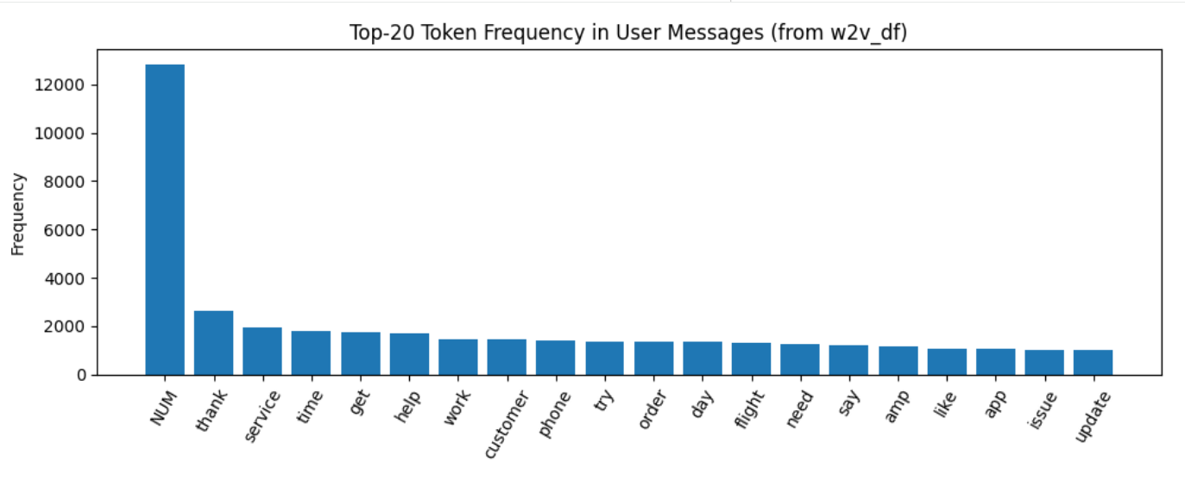
The frequency distribution of the named entity types that the spaCy NER model found is shown in this plot. The most common ones are DATE, CARDINAL, ORG, PERSON, and TIME, and they are based on the prevalent reference to billing period, delivery period, numeric identifiers, and company name in the customer support discussions. On the contrary, other entities like MONEY, PRODUCT, and GPE are less common. The fact that MONEY entities are less frequently detected is indicative of a weakness of general-purpose NER models on informal social media text, in which monetary values are commonly written in non-standard formats. It is implied that entity extraction quality could be enhanced by means of transformer based or domain-adapted NER models. All in all, this discussion demonstrates that entity information, along with intent routing and slot filling, are useful contextual pieces of information, and that the off-the-shelf NER models require modification to noisy conversational data.
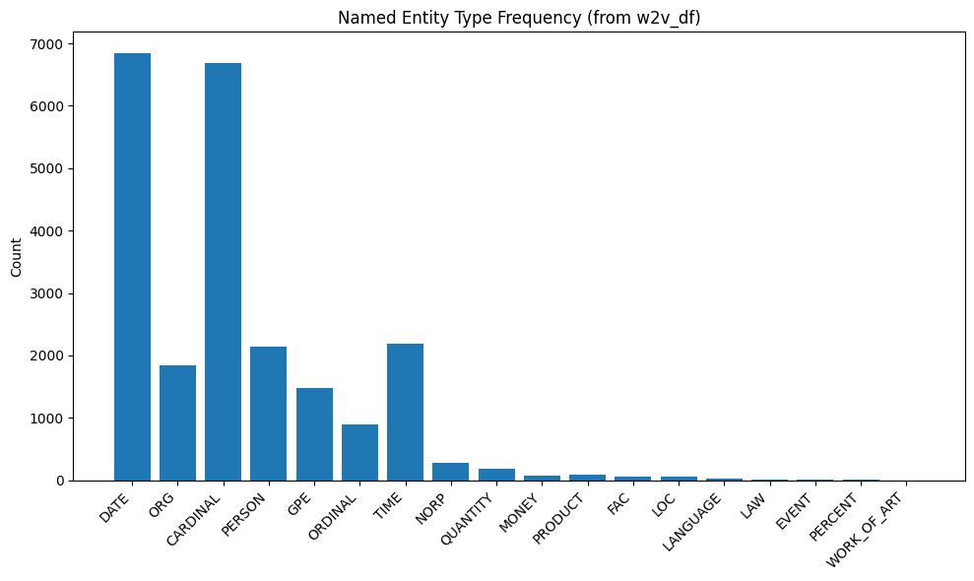
this histogram not only shows the length distribution of the message in tokens, but it has a strong skew towards the right with the majority of messages composed of between 5 to 25 tokens and a long tail of messages with a length of more than 25 tokens. The given pattern is characteristic of real-world conversational data, in which the majority of queries made by users are small and underdefined, and the longer messages are often associated with elaborate complaints or complicated problems. This allocation has significant consequences to chatbot systems. Short inputs create ambiguity and risk of misclassifying intent especially in classical models including TF-IDF that have sparse representations. Whereas transformer models are much more effective in context, they have to be and should be programmed to use the right maximum sequence lengths to avoid unnecessary computation. The observed distribution thus justifies the adoption of 128 token limit during fine-tuning of the transformer since it is inclusive of majority user messages with high efficiency.
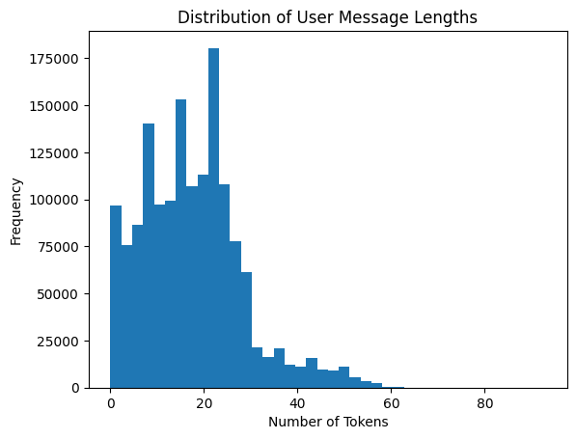
- Intent Distribution Analysis
The distribution of intent is very unbalanced and the other type takes up more data whereas other intents like billing, refund, delivery and technical are much rarer. This is the actual customer support statistics in the real world but it offers a challenge to intent classifiers who might get biased towards the majority and also conceal the poor performance on the high-impact minority intent.This type of imbalance emphasizes the drawbacks in the design of intent taxonomy and demonstrates ethical issues. To deal with this, it is necessary to have strong metrics of evaluation such as weighted F1, the recall per-class, and mitigation to confidence-based fallbacks, hierarchical classification, and human-in-the-loop intervention so that conversational AI systems are reliable and accountable.
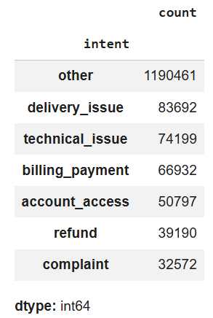

- Word Similarity and Text Similarity Results Analysis
- Word2vec nearest neighbours (Word Similarity Analysis)
the analysis of the Word2Vec reveals that contextually applicable semantic neighbors of their domain-specific keywords (e.g., refund, charge, payment, account, login) are allocated to keywords that were frequently used by customers to resolve problems with the product and the service they require (e.g., dispute, billing, account, access issues, etc.). Retrieved neighbors are not just the similarity of lexical similarity, but rather meaningful relationships in the context of meaning. These findings show that the embeddings are semantically structured with domain knowledge, which is suited to customer service engines even using informal and noisy conversational texts (Mikolova et al., 2013).

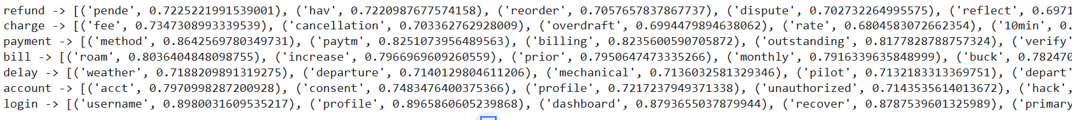
- Sentence-Level Semantic Retrieval: Text Similarity Analysis
The results of semantic retrieval reveal high correspondence between the query submitted by the user and similar messages that happened historically regarding the issues with billing and refund. The system finds semantically related messages in spite of a difference in wording or sentence construction, using Word2Vec generated sentence embeddings as well as cosine similarity, with very high similarity scores (0.920.94). Although this validates the successful semantic retrieval in addition to keyword matching, semantic retrieval is not sufficient to discriminate the finer nuances in the resolution requirement, so a combination with intent classification or rule-based constraints is essential in the actual chatbot platform (Le and Mikolov, 2014; Henderson et al., 2014).

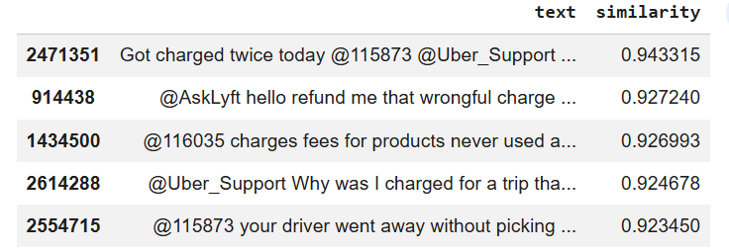

CHAPTER TWO

- Evaluation of TF-IDF & Logistic Regression Classifier
Performance of the TF-IDF and Logistic Regression model is very high in all classes of intents, as majority of the predictions are at the correct location in the diagonal of the confusion matrix. Marginal confusion is observed between intents which are semantically similar (like: billing, payment, refund), as a result of having overlapping vocabulary. The model is robust as indicated by the classification report with large precision, recall and F1-scores (weighted F1 = 0.99, accuracy = 99). Although, performance depends partially on class imbalance, the method is a straightforward, interpretable, and computationally efficient default base in intent recognition in chatbot systems.
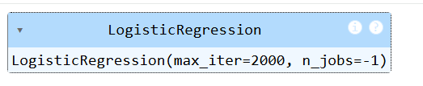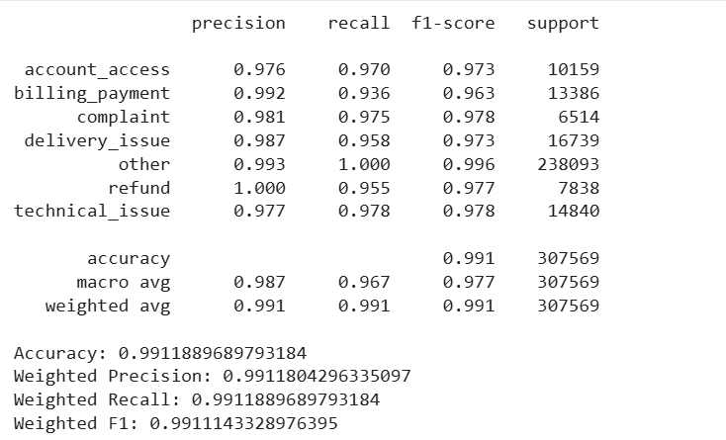

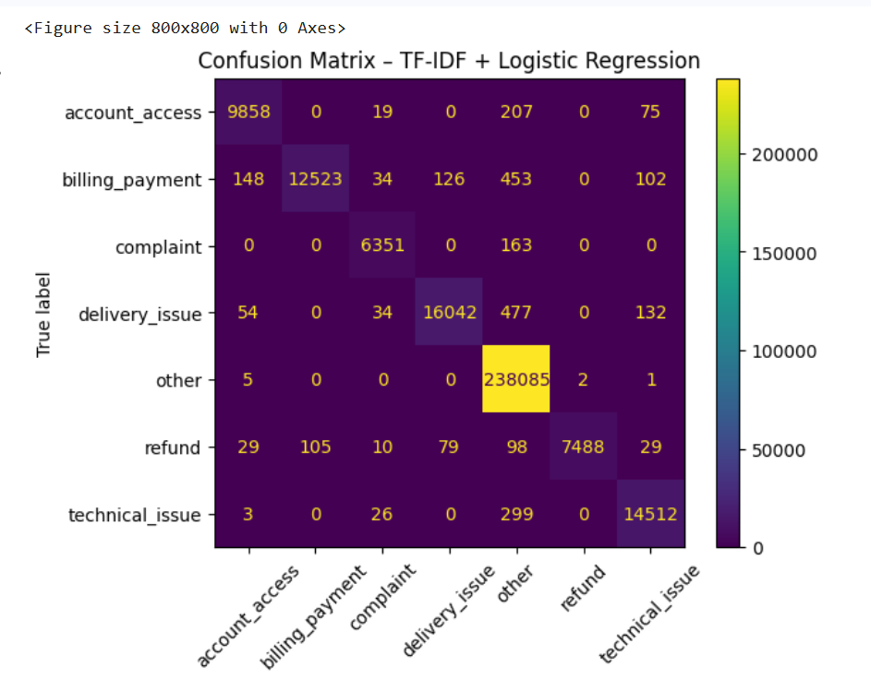
- Word2Vec Embedding Visualization (PCA)
This magnitude depicts a 2D PCA map of word2vec of a sample of common people words. The points diffusion suggests that the model has acquired varied semantic representations instead of reducing words into one section. Even though in two dimensions, there are no sharp clusters, neighboring points are associated with words that are semantically related, which proves that meaningful associations are reflected in the embedding space. This visualization justifies the application of Word2Vec embeddings with the use of semantic similarity and retrieval-based chatbot.
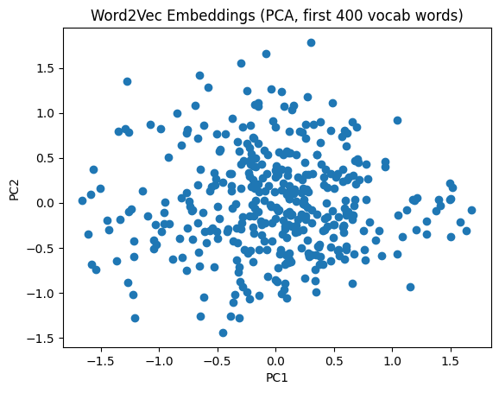

CHAPTER THREE

- Evaluation of DistilBERT Fine-Tuning Results
In the training logs, the DistilBERT model converge very fast in two epochs, where the training and validation loss is observed to continuously decrease with the validation F1- score being observed to increase, with the initial training validation F1-score of 0.9916 increasing to 0.9957. This shows that there is long-term training behavior and a successful adaptation of the pretrained language model to the intent classification task even with only a single number of training epochs.
The classification report shows that its performance has been very high in all the intent classes. Both accuracy and recall are over 0.98 in all the categories as well as minority intents as refund and complaint, which implies that the transformer model is sensitive to contextual inferences that go beyond the superficiality of lexical patterns. When compared to the classical baseline, DistilBERT has a bit higher recall of semantically overlapping intents, which shows its better contextual understanding.
The comparative table shows that although the TF -IDF and Logistic Regression baseline is very close to the good performance, the fine-tuned DistilBERT model offers a slight yet steady advancement in the accuracy and the weighted F1-score. The increase in performance is at the expense of increased computational needs, training time and memory consumption.
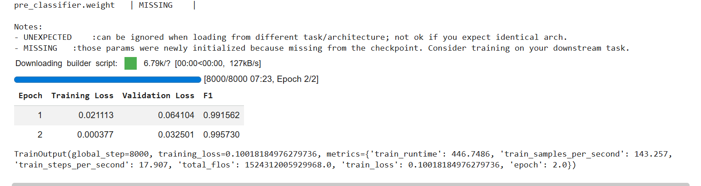
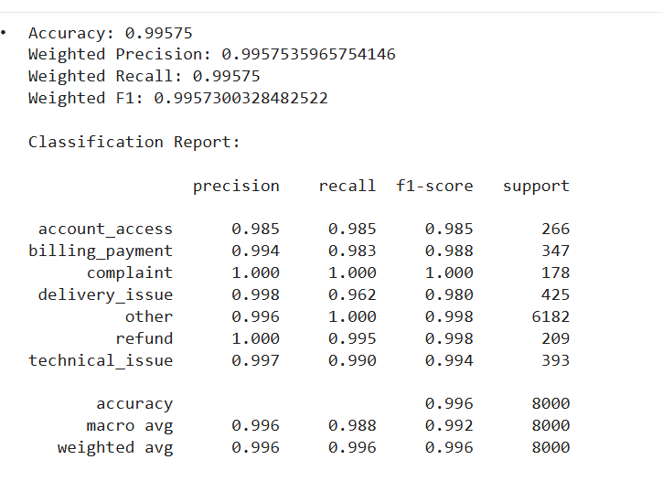
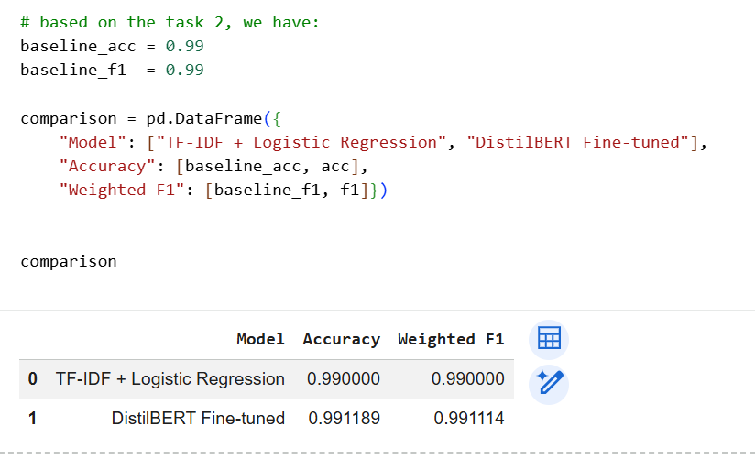

CHAPTER FOUR

Responsible Conversational AI: Risks and Mitigation
- Ethical issues to chatbot
  - Bias in intent classification
The bias of intent classification systems can be increased by biased data, gaps in representation, and labeling. The bias in the distributions of intent in customer support tends to induce the models to give weight to the majority classes forcing a poor performance on high-impact minority intents due to the inclusion of the overall accuracy. Linguistic heterogeneity and poorly controlled labelling also enhance prejudice because models that learn on popular phrasing patterns can fail to perform well when used by users with different phrases that mean the same thing. These concerns demonstrate the necessity of the consideration of fairness during evaluation and subsequent data design.
  - Generation of toxic or harmful responses.
Although the project may not generate complete responses, instead of intent classification, it is common in the real world to have a generation component or template responses with chatbots. The toxicity and harmful content in the generative systems may manifest in the form of training data contamination or adversarial inputs (Gehman et al., 2020). In customer facing, the negative outputs may result in reputational damage and harm to users. Toxicity does not manifest through only profanity, but it also encompasses harassment and discriminatory statements or other dismissive reactions towards vulnerable users. In the case of misclassification (a chatbot directs a message to the wrong portfolio), the chatbot can respond with the wrong template. Indicatively, labeling a distress complaint as a standard billing request may provoke a cold and procedural reaction. The chatbot may be harmful even without being toxic through insensitivity, dismissiveness, or even by being unsafe.
  - Classification error with the result of misguided responses.
The most critical ethical and safety risks in intent-based chatbots are misclassification. An unintentional wrong can happen in customer support:
- ask irrelevant questions such as wasting time, annoying users.
- postpone conflict like deny refund wrongly.
- mishandle sensitive issues like security and account compromise.
- break policy such as solicitude of personal data.
Because of the interactive nature of conversational systems, initial errors are likely to be compounded: a single wrong routing decision may propagate into a series of wrong decisions. This is the reason why a well-developed fallback and uncertainty management is regarded as essential safety requirements (Amershi et al., 2019).
  - Safety considerations of customer facing bots.
Common requirements of customer facing bots are:
- Privacy and data minimization: Do not ask sensitive questions where unnecessary; do not disobey platform and organizational policies.
- Reliability and calibration: Be aware of uncertainty and not to give confident erroneous answers (Guo et al., 2017).
- Transparency: Be open with the user that he or she is communicating with a bot and give points of escalation.
- Monitoring and accountability: Track the decisions, allow human analysis, and continuously analyze failures (Amershi et al., 2019).
Since our data are provided by the public Twitter customer support chats, the privacy threat is lower than in the case of private chats, yet it will still require some caution: messages may include personal information, order numbers, or other types of identifiable data. It involves the use of masks and no reproduction of sensitive contents in outputs.
- Failure Cases
  - Classical baseline failures (TF–IDF and Logistic Regression)
- Semantic proximity of intentions.
TFIDF models are based on lexical signals on the surface and are difficult in cases where similar intentions have common vocabulary. Billing-payment and refund are other terms with similar words as charge, payment, and card in customer support. The fact that TFIDF does not imply meaning except token co-occurrence puts the model at a risk of confusing similar categories.
- Short massages
Numerous user messages are very brief in nature (for instance: help, not working, why). The use of bag-of-words features does not give enough evidence of fine-grained routing and leads the model to frequent classes or other. This is a well-known problem in the intent classification problem having sparse signals.
- Weaknesses in paraphrasing and variability in words
The purpose is the same but stated differently by users (money back, as opposed to refund). TFIDF generalization cannot be made except in the case of strong overlaps in n-grams. This causes mistakes in cases of meaning but wording is different.
- Sensitivity to preprocessing decisions
Critical cues may be removed by stopword removal and aggressive normalization. Although it is common with classical models to preprocess, conversational data may lose significance should cleaning be too vigorous (Manning et al., 2008).
- Weak-label noise effects
Due to the way the labels were generated through keyword rules, incorrect labels on some of the training examples were bound to occur in the intent tags. The classical model can be able to learn spurious correlations (account -> account-access) even in the case where the word is used generically, further amplifying systematic errors.
  - Failures of the transformer model (DistilBERT fine-tuning)
The neural classifiers can give high confidence responses even when their input is not clear. This calibration issue is commonly experienced in current neural networks (Guo et al., 2017). Overconfidence is unsafe in the context of chatbots since it inhibits fallback. Even with a small intent set, DistilBERT has to choose a label. Out of domain query can be redirected to a nearest intent which results in unwanted routing. The robust deployed intent systems require a known requirement of OOS detection (Larson et al., 2019).
Immunity to label noise and imbalance.
Transformers may accommodate complicated figures as well as noise. The model can be learning inconsistent labeling signals in the case of weak supervision. In addition, even rare intents may have lower recall due to the reduced examples that the model is being trained on.
Failing Practical failure modes
Even DistilBERT is also heavier than TF -IDF pipelines. Latency and memory consumption are factors in production and performance improvements should justify costs, particularly in support bots that have to support large traffic.
NLP : prompting strategies
Prompting strategies have become the key to chatbot systems since they enable developers to regulate model behaviour without complete retraining and can enhance robustness under low-data situations. Prompting in customer support chatbots often supplements intent classification and retrieval, as opposed to substituting them. Role prompting refers to the situation where a person or group is prompted to carry out a specific role as a result of their baseline status. The role and restrictions of the assistant that Follow policy, such as do not ask for passwords. According to instruction tuning research, structured instructions can play a significant role in enhancing desired behavior (Ouyang et al., 2022).
- Clarification
In the case of the system being unpredictable, prompts can be created to generate clarifying questions rather than guesses. It is a crucial safety behavior of chatbots: it minimizes erroneous behavior and enhances trust in the users.
- Risks of prompting:
Prompting is not a whole safety measure. It is vulnerable and can be easily injected, and it needs to be integrated with guardrails, monitoring, and fallback logic (Ouyang et al., 2022).
- Mitigation measures
Confidence scores are predicted and based on the result, the chatbot will either react on its own or take a safe fallback. With a low level of confidence, the system may clarify questions, refer to a support menu or escalate the problem to a human agent and minimise the possibility of overconfident misclassification. Also, high-risk situations (for instance, passwords, OTPs, credit card data, abuse) are managed using rule-based patterns, which is a guarantee of safe and predictable behavior. Confidence thresholds alongside rule-based safeguards enhance robustness, and in this case, it is more effective in systems that have been trained on weakly labeled data.
  - Balancing and specific augmentation of data.
In order to correct unbalanced intentions, consider:
- resampling strategies
- gathering additional examples to the underrepresented intents
- controlled augmentation, for instance: paraphrase generation under human evaluation
Handling Imbalance enhances recall of minority-intent and also minimizes biasness to majority classes (He & Garcia, 2009).
4.2. Human override policies
Showing clear paths to escalation:
- billing issues, fraudulent demands, threats/legal concern, extremely emotional complaints.
Human supervision enhances accountability and avoids automation damage, which is appropriate for operational best practices in human-centered AI (Amershi et al., 2019).

CONCLUDING REMARKS

Conclusion
This project, the design of chatbots was explored by classical NLP algorithms, semantic embeddings, and transformer-based models, and responsible conversational AI was in the center stage. Various phases of the chatbot pipeline were tested on actual customer care data both in technical and ethical aspects. It was indicated that preprocessing decision highly impacts performance. TF-IDF using Logistic Regression was simple to interpret, but failed on ambiguous or paraphrased queries. Word2Vec was promising semantic retrieval and fine-tuned DistilBERT was the most accurate intent classifier with higher computational cost. Confidence thresholds, data balancing, fallback strategies, and human-in-the-loop policies tackled conflict models of bias in system ethics and overconfident predictions which serves as an indication of why safety-conscious design is crucial in practice to real-world chatbots implementation.

BIBLIOGRAPHY

References

- Amershi, S., Weld, D., Vorvoreanu, M., Fourney, A., Nushi, B., Collisson, P., Suh, J., Iqbal, S., Bennett, P.N., Inkpen, K., Teevan, J., Kikin-Gil, R. and Horvitz, E. (2019) Guidelines for Human-AI Interaction. Proceedings of the 2019 CHI Conference on Human Factors in Computing Systems (CHI ’19). ACM, New York, pp. 1–13. Available at: https://dl.acm.org/doi/10.1145/3290605.3300233
- Goldberg, Y. and Levy, O. (2014) word2vec Explained: Deriving Mikolov et al.’s Negative-Sampling Word- Embedding Method. arXiv preprint arXiv:1402.3722.
- Guo, C., Pleiss, G., Sun, Y. and Weinberger, K.Q. (2017) ‘On Calibration of Modern Neural Networks’, Proceedings of the 34th International Conference on Machine Learning (ICML), pp. 1321-1330.
- He, H. and Garcia, E.A. (2009) ‘Learning from Imbalanced Data’, IEEE Transactions on Knowledge and Data Engineering, 21(9), pp. 1263-1284.
- Henderson, M., Thomson, B. and Williams, J. (2014) ‘The Second Dialog State Tracking Challenge’, Proceedings of the SIGDIAL Conference, pp. 263-272.
- Lample, G., Ballesteros, M., Subramanian, S., Kawakami, K. and Dyer, C. (2016) ‘Neural Architectures for Named Entity Recognition’, Proceedings of NAACL-HLT, pp. 260-270.
- Larson, S., Mahendran, A., Peper, J.J., Clarke, C., Lee, A., Hill, P., Kummerfeld, J.K., Leach, K., Laurenzano, M.A., Tang, L. and Mars, J. (2019) ‘An Evaluation Dataset for Intent Classification and Out-of-Scope Prediction’, Proceedings of EMNLP-IJCNLP, pp. 1311-1316.
- Le, Q. and Mikolov, T. (2014) ‘Distributed Representations of Sentences and Documents’, Proceedings of the 31st International Conference on Machine Learning (ICML), pp. 1188-1196.
- Mikolov, T., Chen, K., Corrado, G. and Dean, J. (2013) ‘Efficient Estimation of Word Representations in Vector Space’, Proceedings of the International Conference on Learning Representations (ICLR).
- Ritter, A., Cherry, C. and Dolan, W.B. (2011) ‘Data-Driven Response Generation in Social Media’, Proceedings of the Conference on Empirical Methods in Natural Language Processing (EMNLP), pp. 583-593.
- Gehman, S., Gururangan, S., Sap, M., Choi, Y. and Smith, N.A. (2020)
RealToxicityPrompts: Evaluating Neural Toxic Degeneration in Language Models. arXiv preprint arXiv:2009.11462. Available at: https://arxiv.org/abs/2009.11462
- uyang, L., Wu, J., Jiang, X., Almeida, D., Wainwright, C.L., Mishkin, P., Zhang, C., Agarwal, S., Slama, K., Ray, A., Schulman, J., Hilton, J., Kelton, F., Miller, L., Simens, M., Askell, A., Welinder, P., Christiano, P., Leike, J. and Lowe, R. (2022)
Training Language Models to Follow Instructions with Human Feedback. arXiv preprint arXiv:2203.02155. https://doi.org/10.48550/arXiv.2203.02155

APPENDIX (if necessary)

All code can be found at the following link.
https://colab.research.google.com/drive/1ikfZEK7War0qJuNP3yEk65Ry6a7VUaNz#scrollTo=F4tt-m7nnpb9

